Social media catalog

PLUGnPOINT

Contents

Social Media Content Writing 3

Post ID: pnpsm0001 3

Product Name: Aftron Microwave Oven AFMW205MNW 3

Post ID: pnpsm0002 4

Product Name: Super General LED 55" UHD SGLED55AUS9T2 4

Post ID: pnpsm0003 5

Product Name: AUX Split AC 1.5 Ton ASTW18A4/FM 5

Post ID: pnpsm0004 6

Product Name: UGUR Upright Freezer Single Door UED5168DTKNF 6

Post ID: pnpsm0005 7

Product Name: Nikai LED 58" UHD 4K Smart UHD60SLEDT2 7

Post ID: pnpsm0006 8

Product Name: Toshiba Microwave Oven 20L MW-MM20P(WH) 8

Post ID: pnpsm0007 9

Product Name: West Point Cooker 90cm WCE-9060HDFS 9

Post ID: pnpsm0008 10

Product Name: Ultrasonic Wave Humidifier 3.0L (Ultrasonic Wav) 10

Post ID: pnpsm0009 11

Product Name: Samsung Washing Machine Front Load 9KG WW90T3040WW 11

Post ID: pnpsm0010 12

Product Name: Toshiba Water Dispenser RWF-W1766TU(W) 12

Post ID: pnpsm0011 13

Product Name: Geepas Dry Iron GDI23012 13

Post ID: pnpsm0012 14

Product Name: Kodama Electric Oven 60L 2200W KEOTG-60L 14

Post ID: pnpsm0013 15

Product Name: Nikai Blender NB1717T2 15

Post ID: pnpsm0014 16

Product Name: Nikai Refrigerator Single Door Sil NRF130SS1 16

Post ID: pnpsm0015 17

Product Name: Aftron Water Dispenser AFWD5780 17

Post ID: pnpsm0016 18

Product Name: Blue Star Window Ac 1.5Ton Rotary E1WAM18CCYRA 18

Post ID: pnpsm0017 19

Product Name: Nikai Glass Kettle 1.2 Ltr. NK303G 19

Post ID: pnpsm0018 20

Product Name: Hisense Washing Machine 7KG Front Load WFHV7012T 20

Post ID: pnpsm0019 21

Product Name: Touchmate 2 Slice Toaster TMTS200 21

Post ID: pnpsm0020 22

Product Name: Frigidaire Deep Fryer FDDF-1002 22

Post ID: pnpsm0021 23

Product Name: Nikai Kitchen Machine 1200W NSM650A 23

Post ID: pnpsm0022 24

Product Name: Kodama Cooking Range 57x57 KCR-5757FS(RED) 24

Post ID: pnpsm0023 25

Product Name: Nikai LED 65" Smart UHD (T2) UHD65SLEDT2 25

Post ID: pnpsm0024 26

Product Name: TCL Split AC 1.5 Ton TAC-18CSA/XA81 26

Post ID: pnpsm0025 27

Product Name: Aftron Microwave Oven AFMW205MNW 27

Post ID: pnpsm0026 28

Product Name: Nikai Window AC 1.5 Ton Rotary R-4 NWAC18031N11 28

Post ID: pnpsm0027 29

Product Name: Super General Washing Machine Front Load SGW6100NLED 29

Post ID: pnpsm0028 30

Product Name: Touchmate 4 Slice Toaster TMTS400 30

# Social Media Content Writing

## Post ID: pnpsm0001

### Product Name: Aftron Microwave Oven AFMW205MNW

**Post Contents:**

**New Contents**

**Hash Tags:**

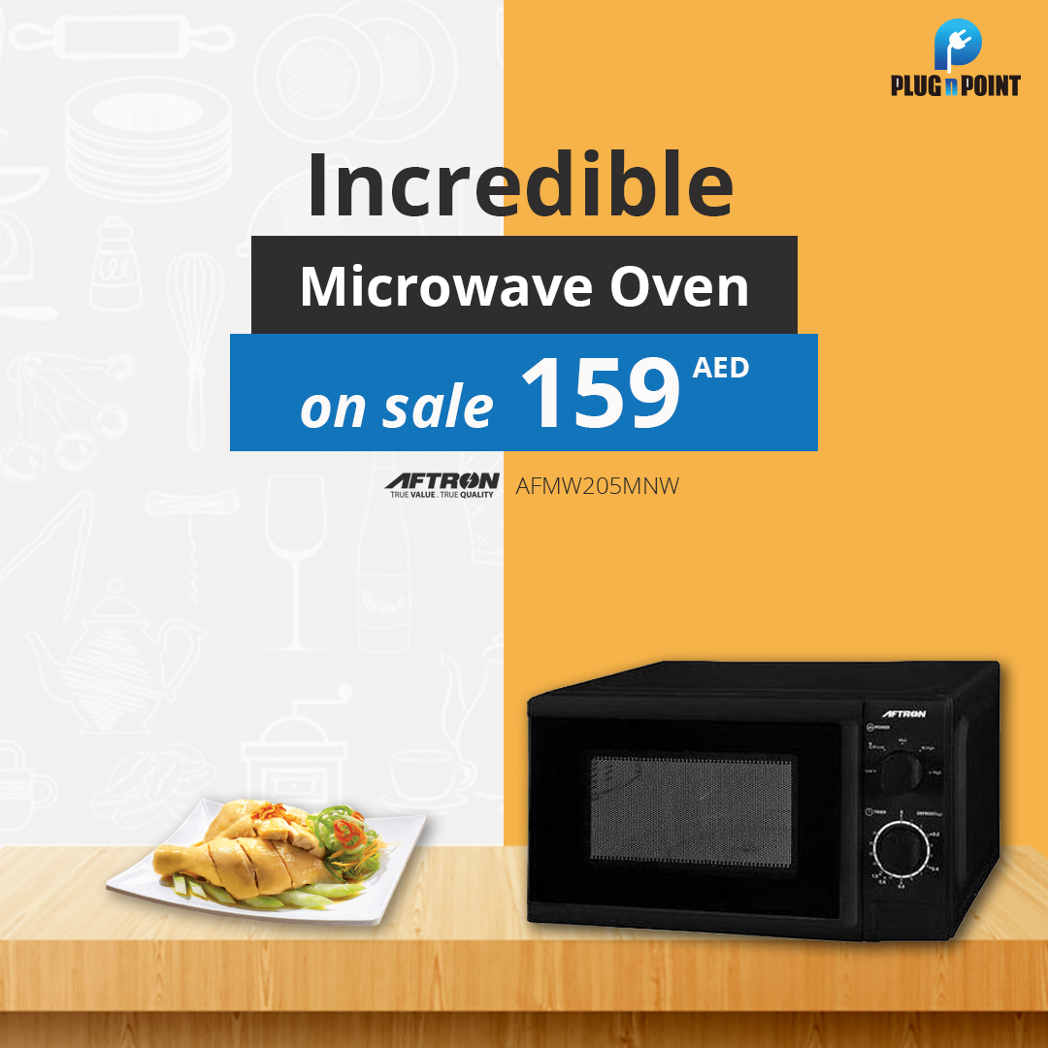

## Post ID: pnpsm0002

### Product Name: Super General LED 55" UHD SGLED55AUS9T2

**Post Contents:**

**This change**

**Hash Tags:**

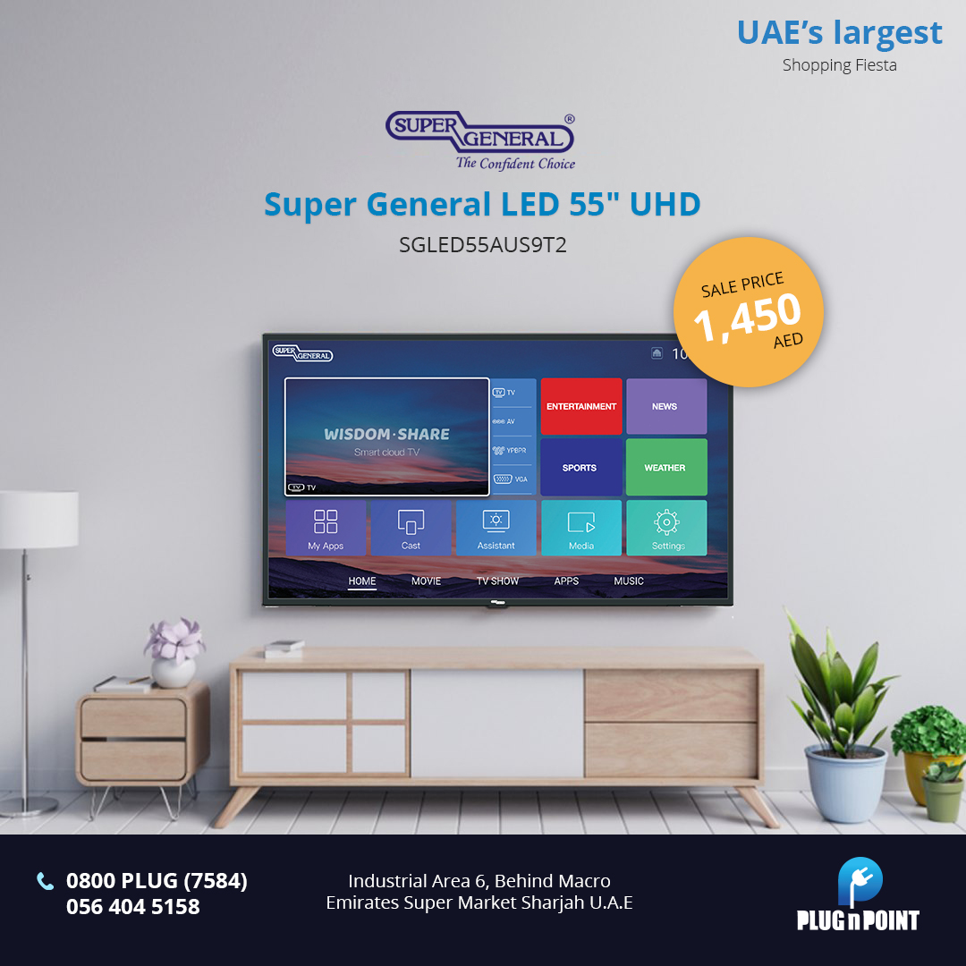

## Post ID: pnpsm0003

### Product Name: AUX Split AC 1.5 Ton ASTW18A4/FM

**Post Contents:**

**Hash Tags:**

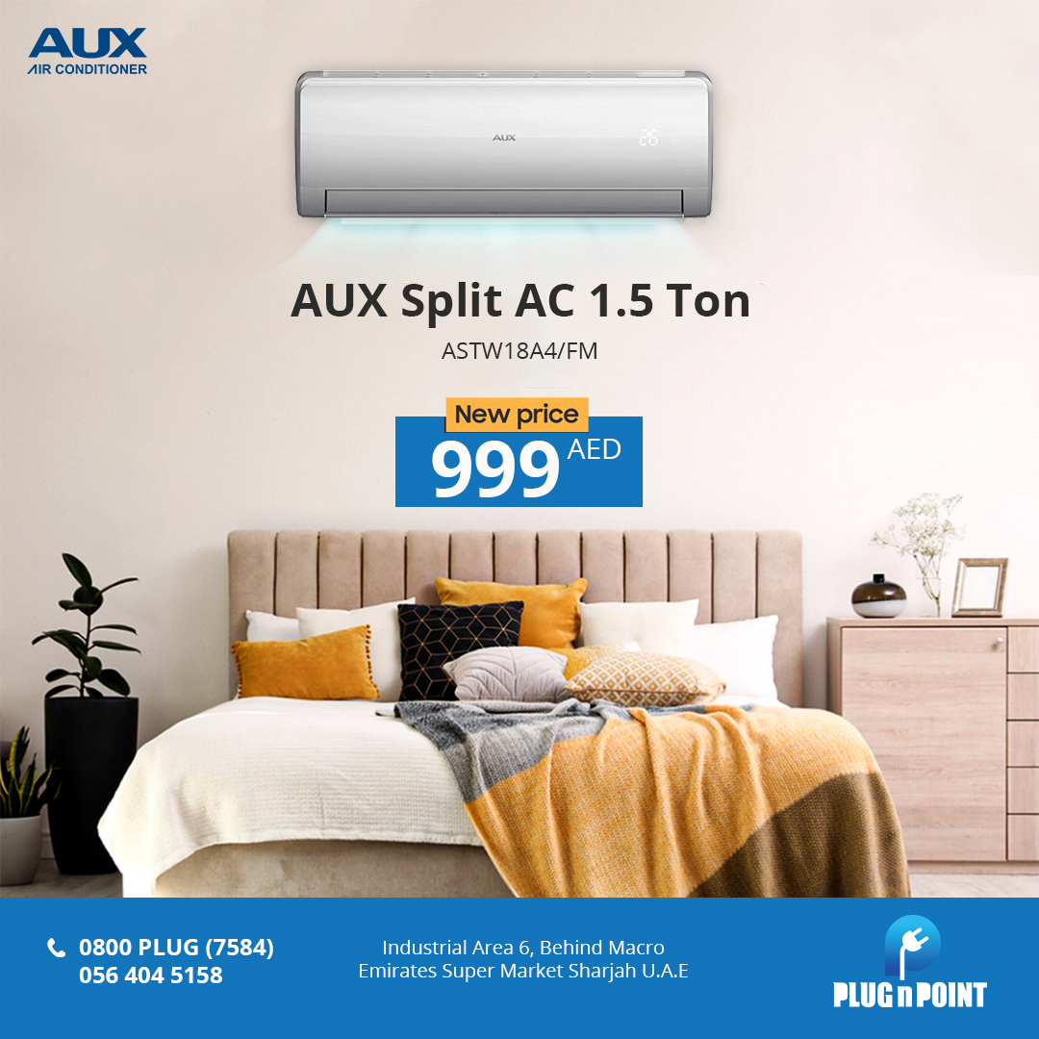

## Post ID: pnpsm0004

### Product Name: UGUR Upright Freezer Single Door UED5168DTKNF

**Post Contents:**

**Hash Tags:**

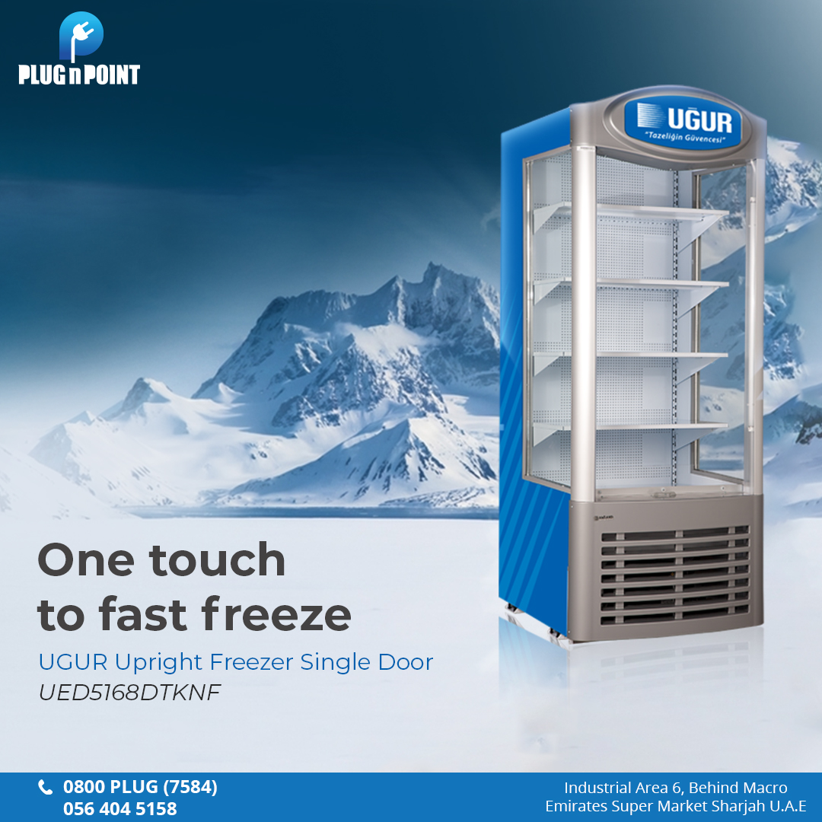

## Post ID: pnpsm0005

### Product Name: Nikai LED 58" UHD 4K Smart UHD60SLEDT2

**Post Contents:**

**Hash Tags:**



## Post ID: pnpsm0006

### Product Name: Toshiba Microwave Oven 20L MW-MM20P(WH)

**Post Contents:**

**Hash Tags:**

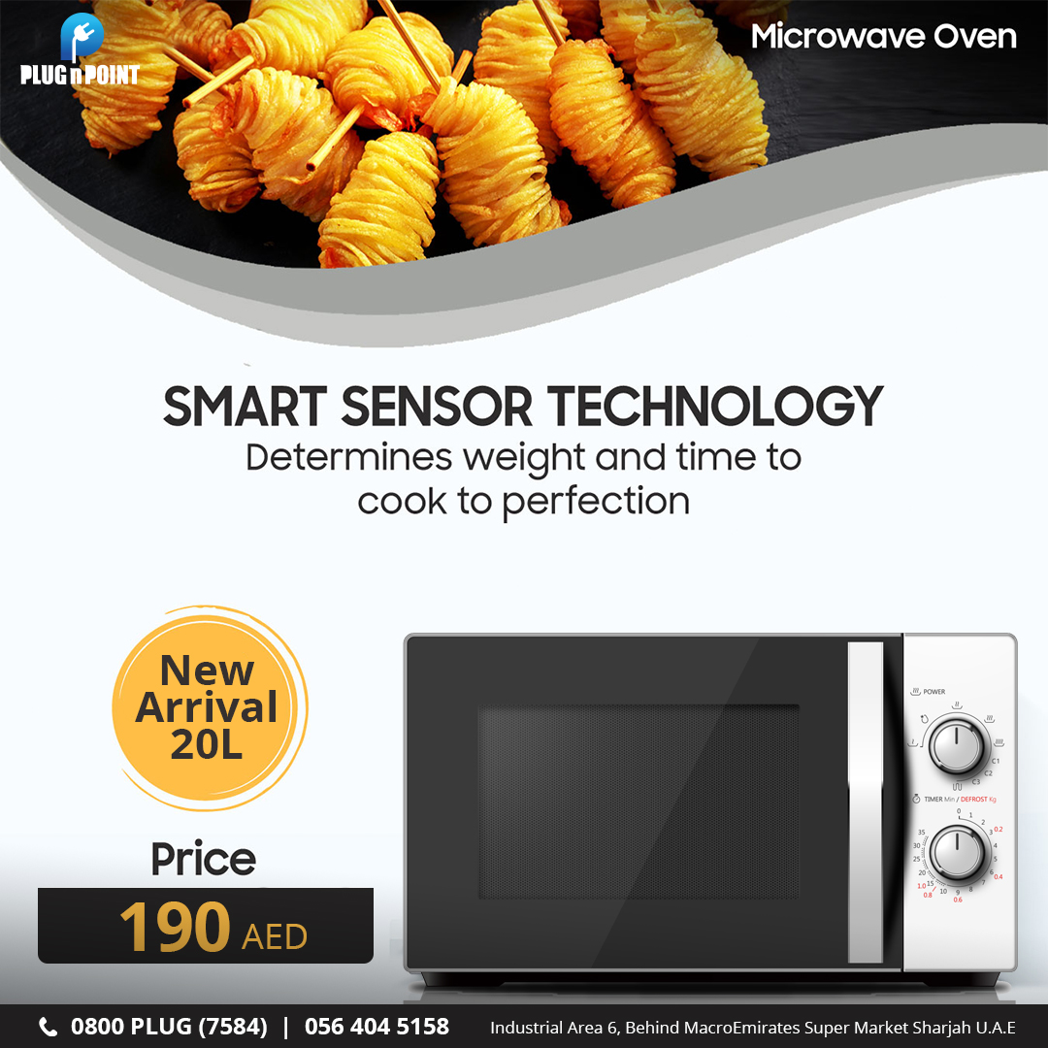

## Post ID: pnpsm0007

### Product Name: West Point Cooker 90cm WCE-9060HDFS

**Post Contents:**

**Hash Tags:**



## Post ID: pnpsm0008

### Product Name: Ultrasonic Wave Humidifier 3.0L (Ultrasonic Wav)

**Post Contents:**

**Hash Tags:**



## Post ID: pnpsm0009

### Product Name: Samsung Washing Machine Front Load 9KG WW90T3040WW

**Post Contents:**

**Hash Tags:**

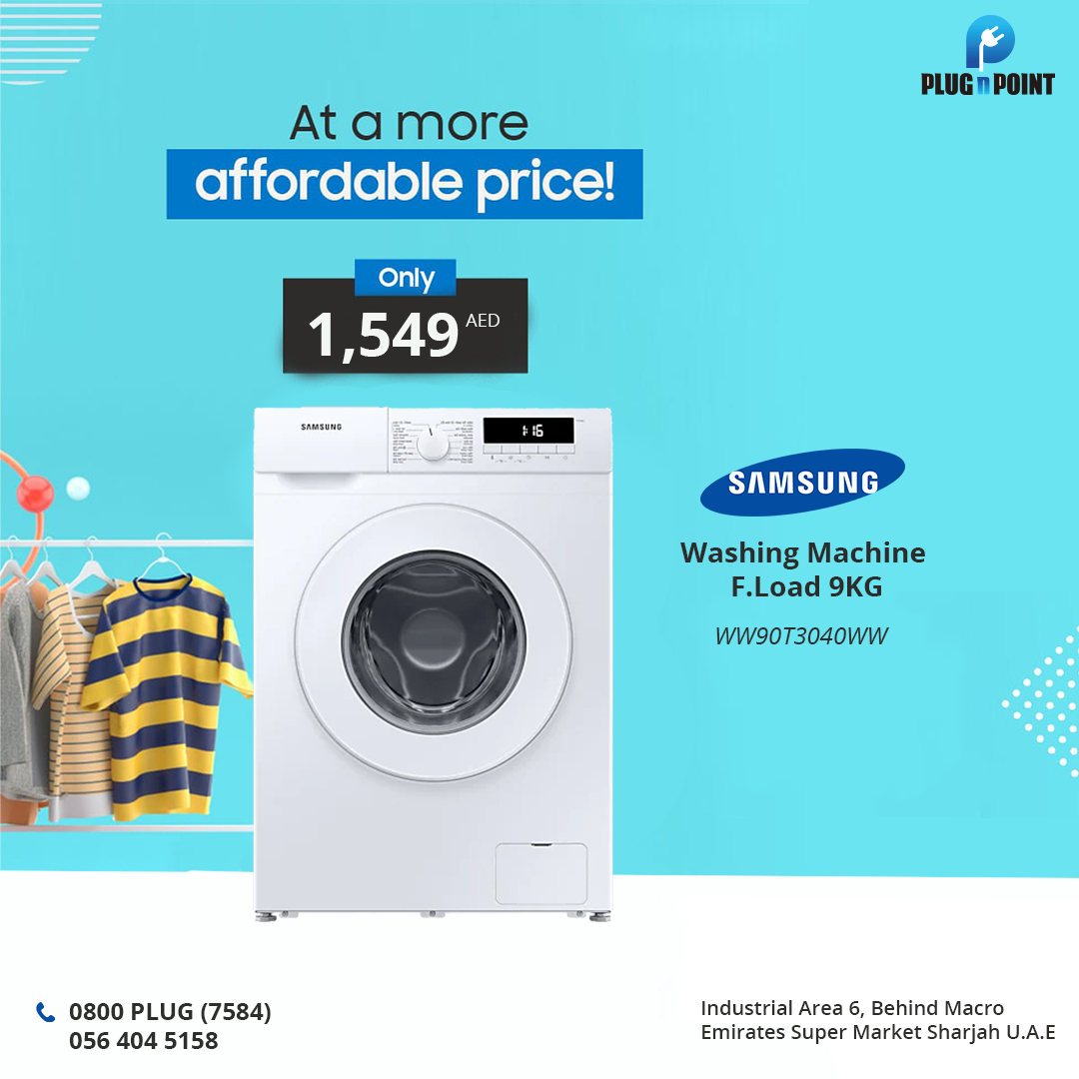

## Post ID: pnpsm0010

### Product Name: Toshiba Water Dispenser RWF-W1766TU(W)

**Post Contents:**

**Hash Tags:**

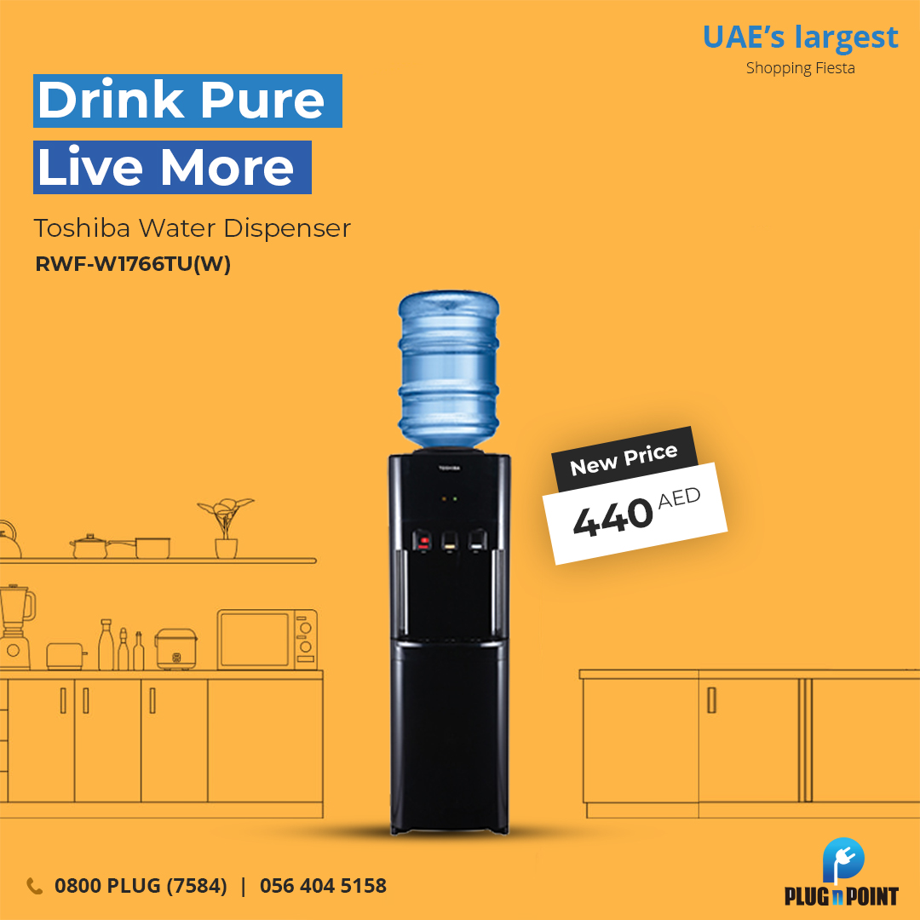

## Post ID: pnpsm0011

### Product Name: Geepas Dry Iron GDI23012

**Post Contents:**

**Hash Tags:**



## Post ID: pnpsm0012

### Product Name: Kodama Electric Oven 60L 2200W KEOTG-60L

**Post Contents:**

**Hash Tags:**

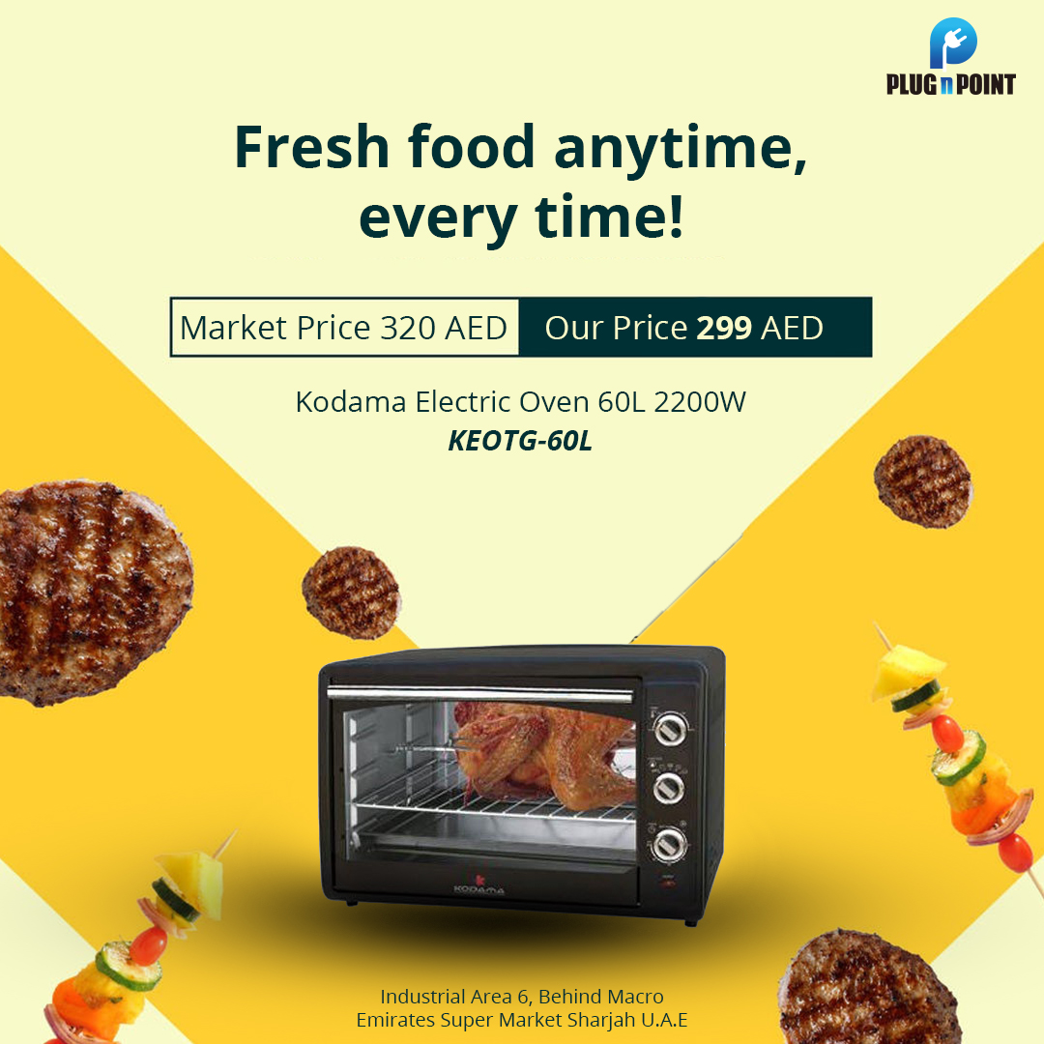

## Post ID: pnpsm0013

### Product Name: Nikai Blender NB1717T2

**Post Contents:**

**Hash Tags:**

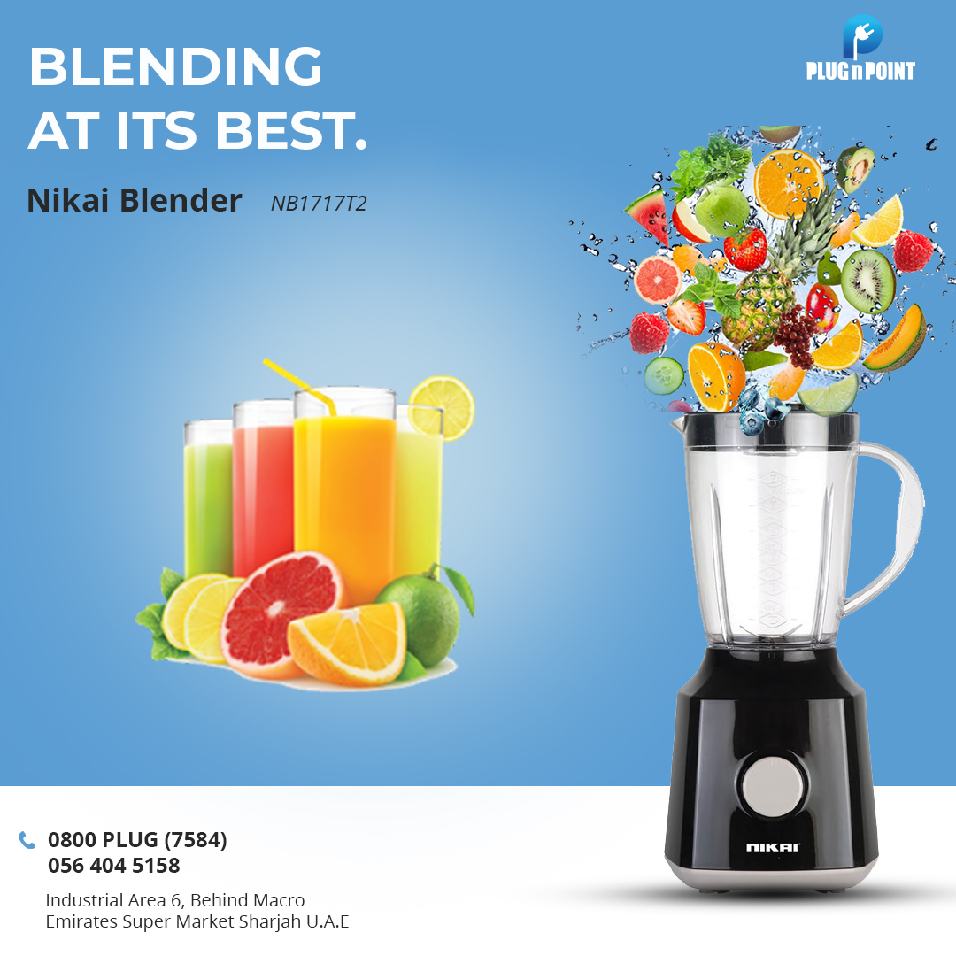

## Post ID: pnpsm0014

### Product Name: Nikai Refrigerator Single Door Sil NRF130SS1

**Post Contents:**

**Hash Tags:**

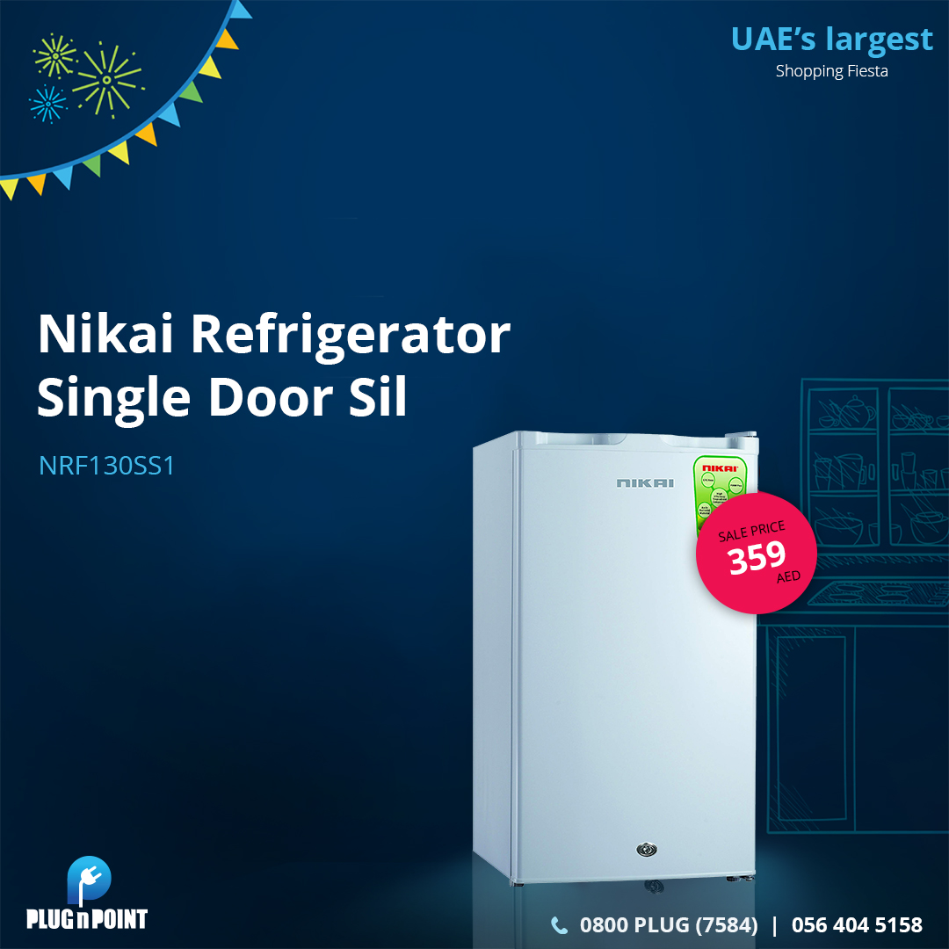

## Post ID: pnpsm0015

### Product Name: Aftron Water Dispenser AFWD5780

**Post Contents:**

**Hash Tags:**

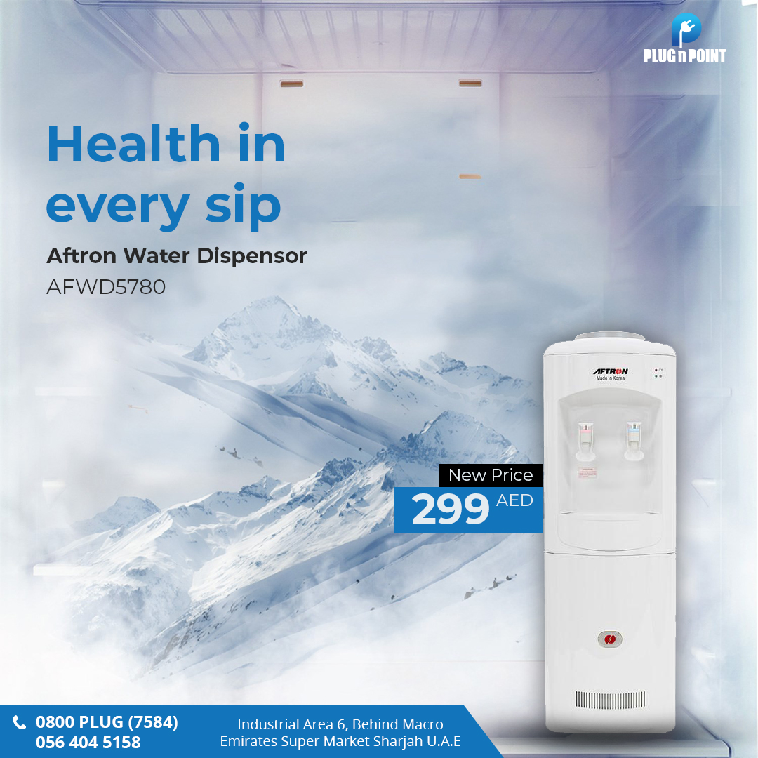

## Post ID: pnpsm0016

### Product Name: Blue Star Window Ac 1.5Ton Rotary E1WAM18CCYRA

**Post Contents:**

**Hash Tags:**



## Post ID: pnpsm0017

### Product Name: Nikai Glass Kettle 1.2 Ltr. NK303G

**Post Contents:**

**Hash Tags:**

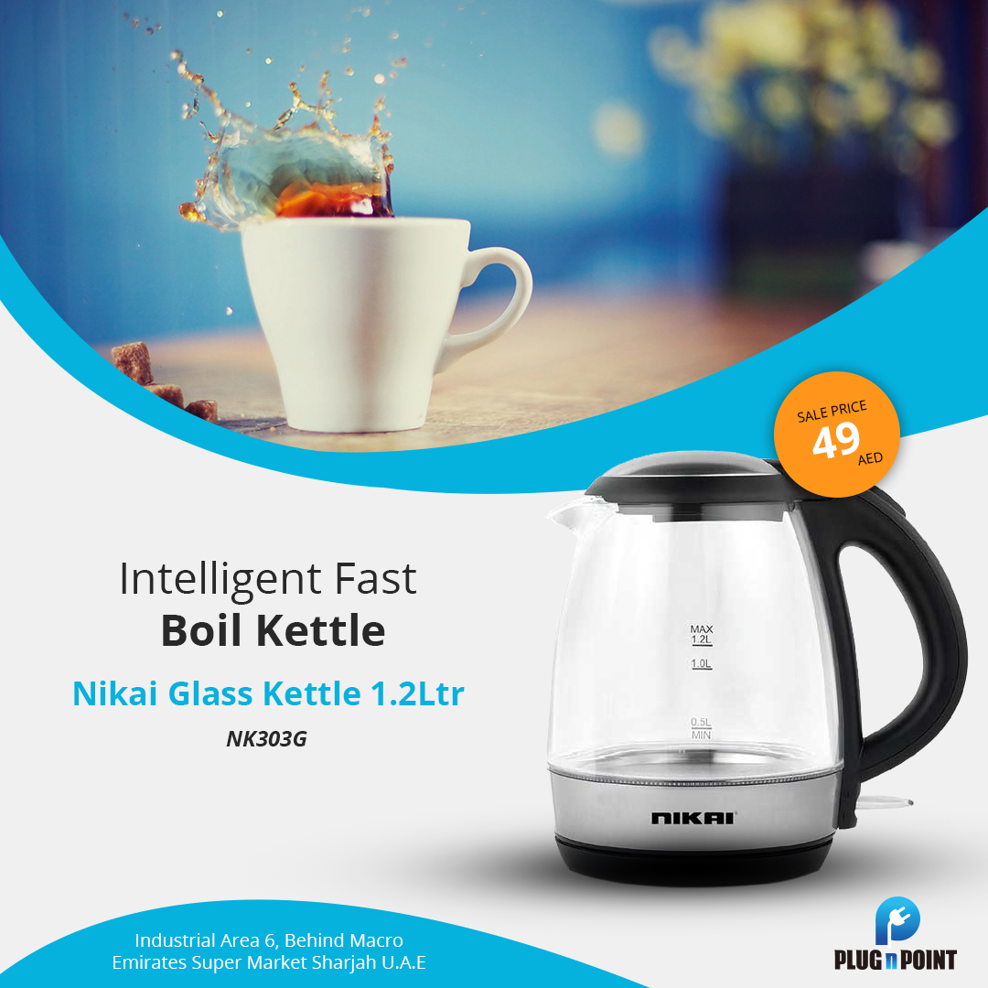

## Post ID: pnpsm0018

### Product Name: Hisense Washing Machine 7KG Front Load WFHV7012T

**Post Contents:**

**Hash Tags:**



## Post ID: pnpsm0019

### Product Name: Touchmate 2 Slice Toaster TMTS200

**Post Contents:**

**Hash Tags:**

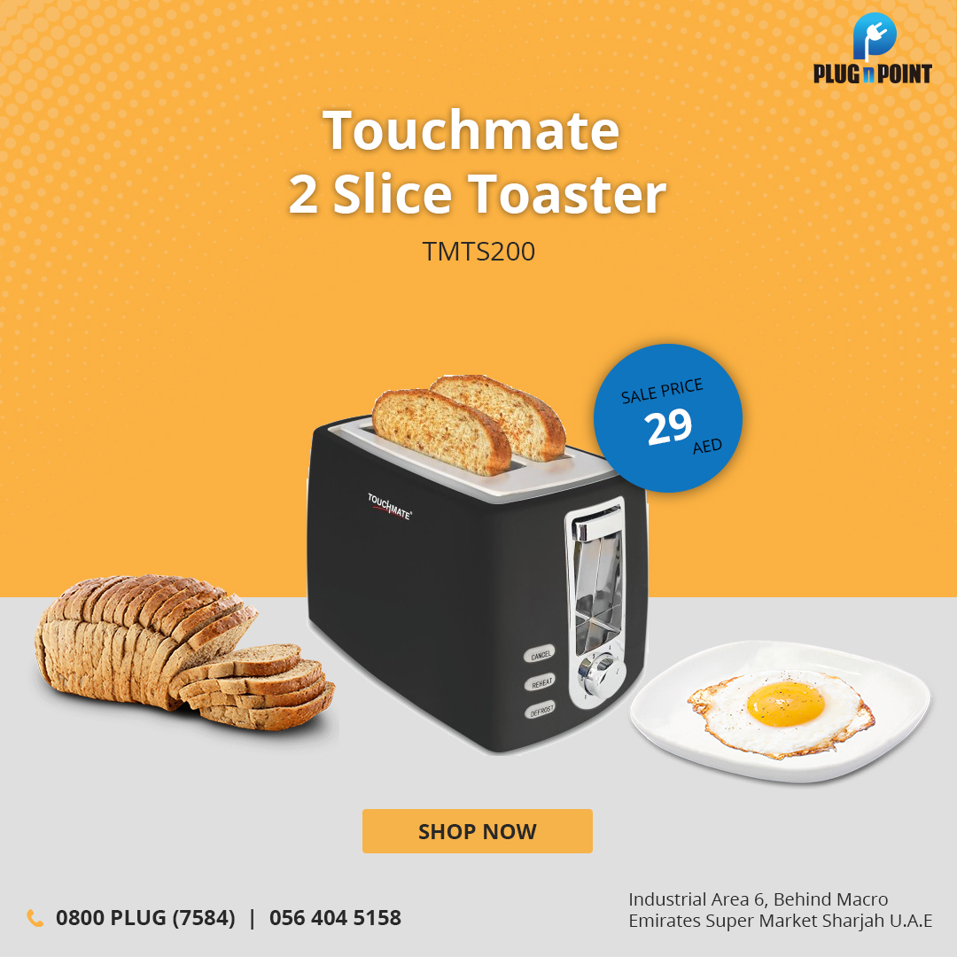

## Post ID: pnpsm0020

### Product Name: Frigidaire Deep Fryer FDDF-1002

**Post Contents:**

**Hash Tags:**

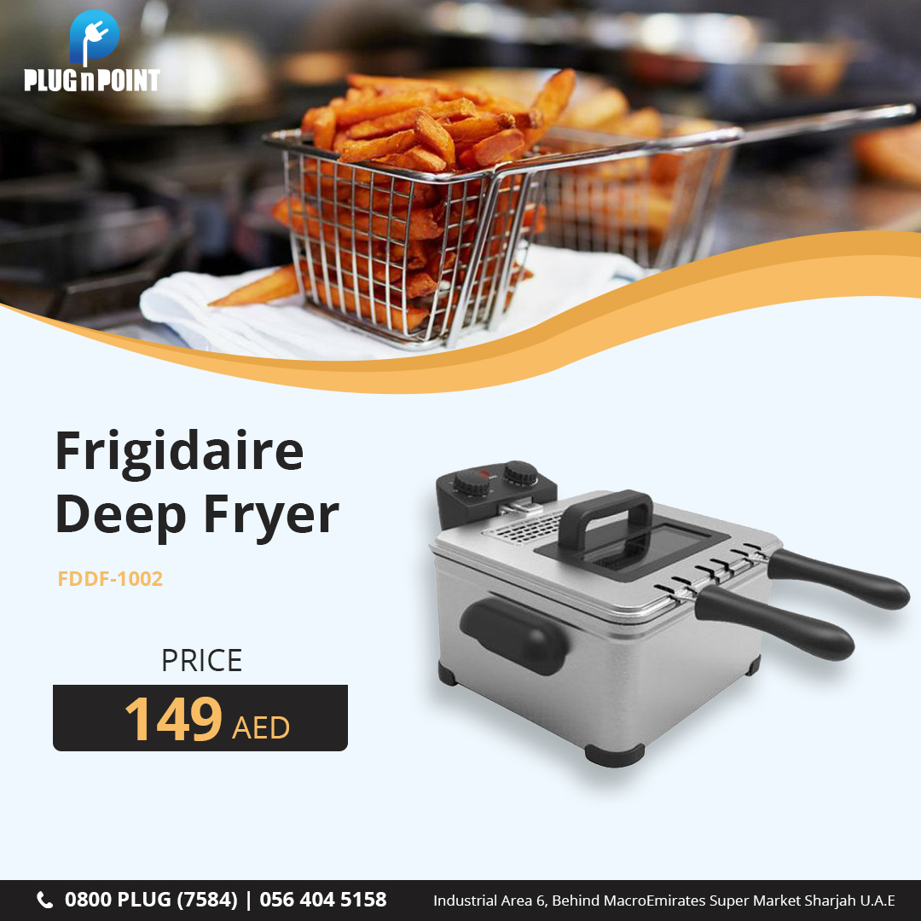

## Post ID: pnpsm0021

### Product Name: Nikai Kitchen Machine 1200W NSM650A

**Post Contents:**

**Hash Tags:**

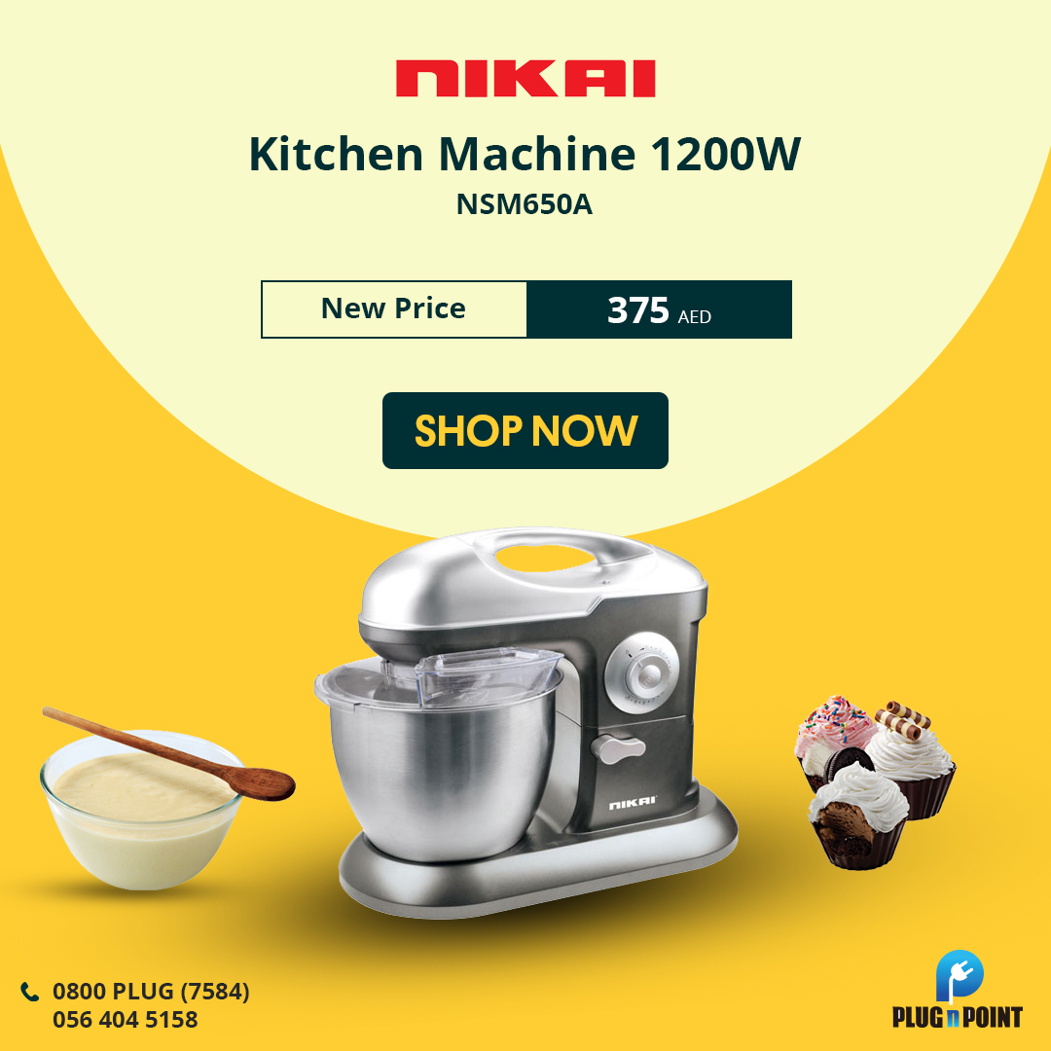

## Post ID: pnpsm0022

### Product Name: Kodama Cooking Range 57x57 KCR-5757FS(RED)

**Post Contents:**

**Hash Tags:**



## Post ID: pnpsm0023

### Product Name: Nikai LED 65" Smart UHD (T2) UHD65SLEDT2

**Post Contents:**

**Hash Tags:**

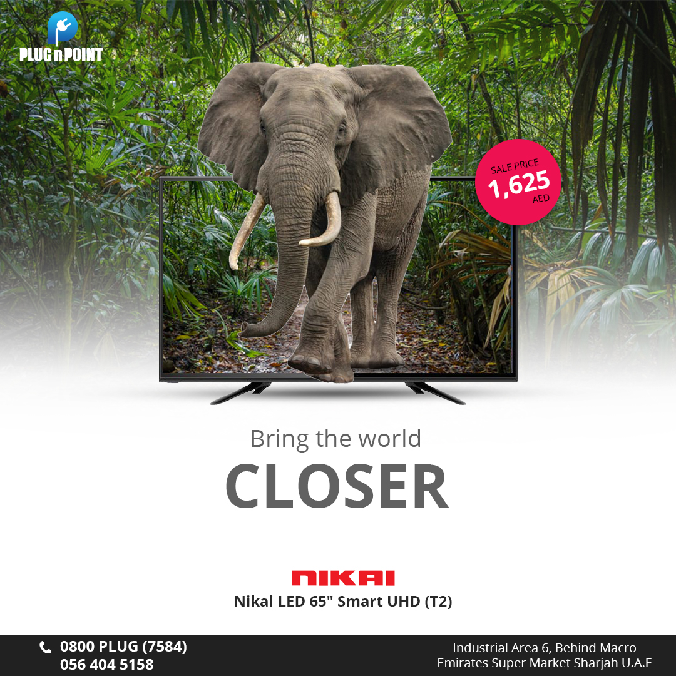

## Post ID: pnpsm0024

### Product Name: TCL Split AC 1.5 Ton TAC-18CSA/XA81

**Post Contents:**

**Hash Tags:**

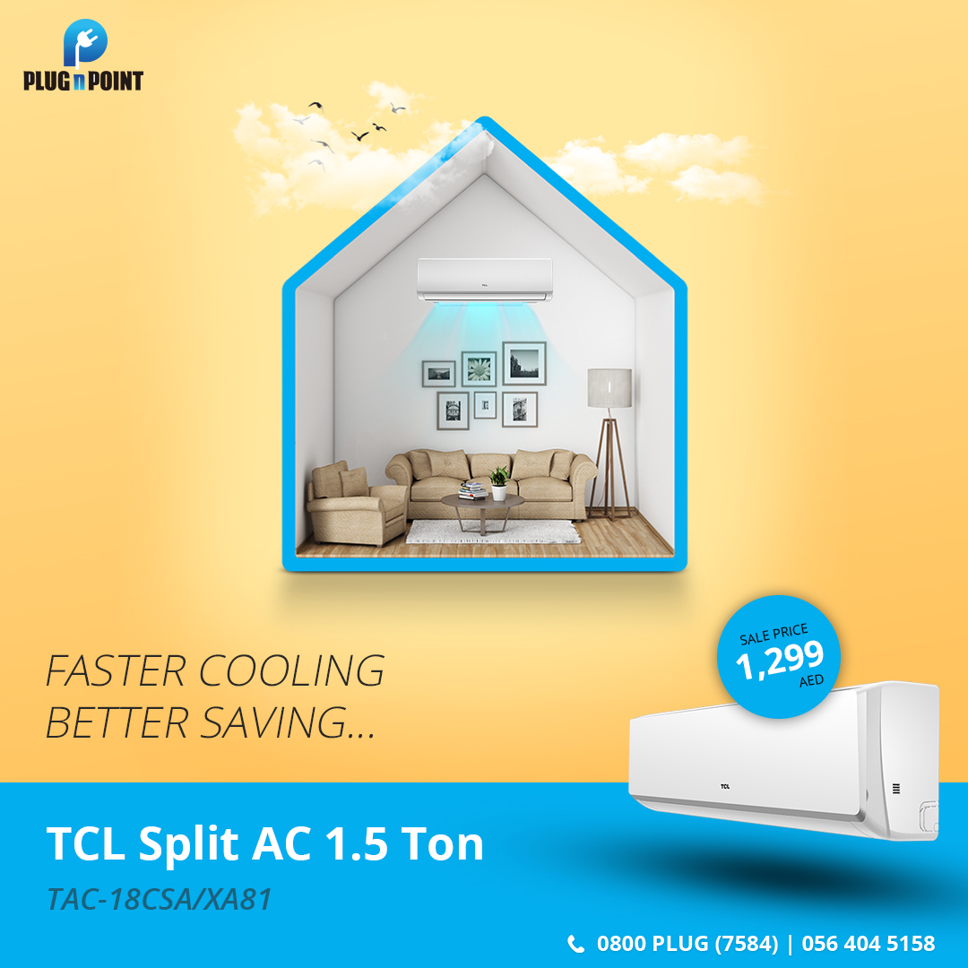

## Post ID: pnpsm0025

### Product Name: Aftron Microwave Oven AFMW205MNW

**Post Contents:**

**Hash Tags:**



## Post ID: pnpsm0026

### Product Name: Nikai Window AC 1.5 Ton Rotary R-4 NWAC18031N11

**Post Contents:**

**Hash Tags:**



## Post ID: pnpsm0027

### Product Name: Super General Washing Machine Front Load SGW6100NLED

**Post Contents:**

**Hash Tags:**



## Post ID: pnpsm0028

### Product Name: Touchmate 4 Slice Toaster TMTS400

**Post Contents:**

**Hash Tags:**

